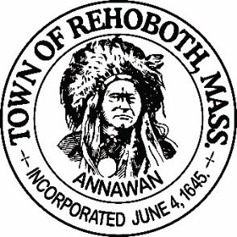

REHOBOTH TOWN EVENTS COMMITTEE

Meeting Minutes

Location: Rehoboth, Massachusetts, remote via Zoom
Date: January 25, 2021 at 6:00 pm

Attendance: David LeComte, Jennifer LeComte, Odete LaCourse and Sheila Kramer

Absent: Dawn Crooks and Liz Fischbach

Motion to approve the minutes from December 28, 2020 was made by Odete, seconded by Jen. Discussion: None. All in favor.

Agenda Items:
Committee update: Deborah Breckenridge has resigned from the committee. Dave was dismayed by her decision to leave as she has done so much for the committee and for the Taste of Rehoboth. Odete suggests a letter of appreciation which Dave will write. Hopefully she will reconsider when we are able to have the TOR again. Dawn will submit a letter of resignation but we have not heard anything from Liz at this point.
Recruitment: Jen will reach out to all of the participants of the porch decorating contest and Light Up Rehoboth contest to see if any of them are interested in joining the committee. Odete suggested including a link to the talent bank form. Jen will also put out something on Facebook. We also have a writeup in the Rehoboth Reporter for next month and on the Town website looking for volunteers. Odete reached out to a couple of people who are interested in joining the committee and they will submit a talent bank form.
Town Events Facebook page: Dave reached out to Connie Wenzel-Jordan about setting this up but she declined. Odete suggested that we utilize the other town Facebook pages to promote our events. We should discuss this idea with the administrators of those sites. David thinks we should have our own page and email address. We will revisit this at another time.
Town website updates: David will be responsible for posting the agendas and minutes from our meetings. Odete will be responsible for updating the site and posting pictures, events, event dates etc.… Odete will have to sit with Laura Schwall to be brought up to date on what can and cannot be done. The town clerk is busy with the town census and town elections coming up so this will have to wait until she has time.
Finance report: Our current balance is $1567.28. We brought in $310 from the Light Up Rehoboth contest and spent $306.16 for prizes. Odete suggested that for our next event, we try to put aside a little more revenue in order to support future events. We can spend less on prizes and/or raise the entry fees.
Taste of Rehoboth: Sadly, we will probably have to cancel this year’s TOR also due to Covid-19.
Scavenger Hunt: Dave is still developing ideas for this. Dave feels this may be a more significant event than expected due to the continuing Covid-19 restrictions and the TOR being delayed. He is still looking into ways of running a scavenger hunt. There is a town in Indiana that recently did one and he has a call scheduled with the people that ran the event. Dave reviewed his ideas with us and is learning the technical aspect of it, as well as the financial implications. Sheila thinks is sounds complicated. Jen thinks we should keep the rules simple. Odete likes the idea as there are a lot of interesting things in Rehoboth. She suggests that we talk to the Librarian or the Antiquarian Society to get ideas on what to include. We will tentatively plan this event for mid-May.
New Business: None.
Next Meeting: Monday February 22nd at 6:00 via Zoom.
Motion to adjourn at 6:44pm was made by Jen, seconded by Sheila and all in favor

Respectfully submitted,

Jennifer Lecomte

Meeting Minutes Approved (date and time):

Date: __5/9/21______ Time: __1:00PM

Signature of The Town Event Committee Chairman
after minutes have been approved:

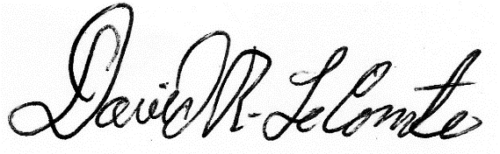
________________________________________
David LeComte – Chairman

