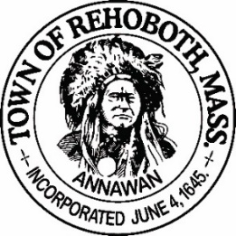

REHOBOTH TOWN EVENTS COMMITTEE

Meeting Minutes

Location: Dunkin Donuts, RT 44 Rehoboth, MA
Date: December 2, 2021 at 5:30 pm

Attendance: David LeComte, Jennifer LeComte, Sheila Kramer and Kelli Trexler

Absent: Odete Lacourse and Regan Furtado

Agenda Items:

Approval of Minutes - Motion to approve the minutes from November 4, 2021 was made by Sheila, seconded by Kelli. Discussion: Jen noted one error in the Finance report and she will clear up the discrepancy with the town accountant. Otherwise, all in favor.

Finance report: Our current balance is $2018.39. This includes all sponsorship donations and entrants to Light Up Rehoboth as of 11/29/21. There was also a disbursement of $158.89 to reimburse David for the prizes for the Porch Decorating Contest.
Light Up Rehoboth: So far, we have 15 residents signed up. Kelli will put up fliers around town this week. Please continue to share posts on social media. Dave will make a list of addresses to be posted once all the registrations are in. Kelli picked up the ornaments for all participants. They look great. We will distribute them as we go out to judge the displays. Motion made by Sheila to approve the ornaments, second by Kelli and all in favor. We reviewed the judging criteria for the contest and distributed judging forms to all. Please rate each house from 1-100 in all categories.
Prizes: We discussed obtaining locally sourced prizes and making baskets for each award. We have 5 gift cards and $450 cash. Some ideas put out were: cheeses, meats, candies, gourmet candy apples, and soaps. Think about it this week and we will decides next week.
New Business: Sheila brought up that we should update the sponsorship letter next year. We should maybe add the Light Up Rehoboth headline to the letter to brighten it up a bit.
Next Meeting: To be determined.
Motion to adjourn at 6:25 pm was made by Kelli, seconded by Dave and all in favor

Respectfully submitted,

Jennifer Lecomte
Clerk – Town of Rehoboth Events Committee

Meeting Minutes Approved (date and time):

Date: ___________________________ Time: ____________

Signature of The Town Event Committee Chairman
after minutes have been approved:

________________________________________
David LeComte – Chairman

