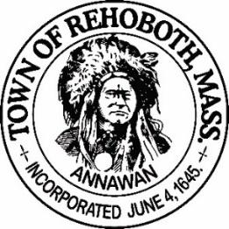

REHOBOTH TOWN EVENTS COMMITTEE

Meeting Minutes

Location: Dunkin Donuts, RT 44 Rehoboth, MA
Date: October 6, 2021 at 6:00 pm

Attendance: David LeComte, Jennifer LeComte, Regan Furtado, Odete Lacourse, Sheila Kramer and Kelli Trexler

Absent: None

Agenda Items:

Approval of Minutes - Motion to approve the minutes from July 26, 2021 was made by Sheila, seconded by Odete. Discussion: Jen noted one error in the notes and corrected it. All in favor.

Recruitment update: Welcome to Kelli Trexler, the newest member of our committee. Odete, Sheila and David have been reappointed and sworn in. Regan is also a full member. Jennifer can only be an associate member and cannot vote on anything. We have three other talent bank forms submitted but they have not been appointed and sworn in yet.
Elections: At the next meeting we will be holding elections for Chair, Vice Chair and Clerk/Treasurer.
Finance report: Our current balance is $1657.28. No change from the last meeting. Sheila moved to accept the finance report as stated, Kelli seconded and all in favor
Fall Porch Decorating Contest: Dave will create a Town Events email for participants to register. We need at least three of us to go out on judging nights. We made a couple of small changes from last years contest. 1) We will have 2 categories Best Halloween display and Best Traditional Fall display. 2) Prizes. We will have a plaque made for the winners. Sheila made a motion to have Dave design and order the two plaques, Regan seconded this and all in favor. 3) Mapping. We did not do this last year but this year we will put out a list of the address’s so others can go out and enjoy the displays. Kelli will design a flyer for the event and Odete will add it to the Town website. We will provide a link to get to the registration and rules. Once it is all set, we can share it on social media sites.
Light Up Rehoboth: Sheila made a motion to run the Light Up Rehoboth Contest again this year. Seconded by Regan and all in favor. We discussed a few changes from last year, namely promoting it a little earlier, cost of registration, looking for donation and/or sponsors for the prizes, how many prizes to give, better mapping of the locations and getting it on the town website.
Prizes: We discussed approaching businesses in town and asking them to sponsor the contest and in return we would put their company name on the flyers/promotions. We could put a request on Rehoboth Talk to see if any businesses would like to volunteer. We discussed having a Gold ($50)/Silver ($30) and Bronze ($20) level of sponsorship. We will all contact 5 business looking for sponsorship. We would have the winners pick up their prize at the business also. We also discussed looking into a “participation award” for everyone who enters. Something small, like an ornament. Kelli will look into this with Vista Print or other companies.
Cost for registration: We will increase the cost to $15 this year. Motion was made by Sheila to increase the price the $15, Seconded by Kelli and all in favor.
Date: December 10-18 with winners announced on the 19th
New Business: At the last meeting, Regan suggested that during the holiday season we could have a Holiday Sing A Long at the Gazebo. We could check with Doug Kelly (High School Band Director) about getting some musical accompanist and choral singers. Regan will flesh out some of the details and we will discuss it further at the next meeting. We could also coordinate this with the Light Up Rehoboth Event (Maybe announce the winners at the Sing A Long). We were not able to discuss this idea tonight other than checking with the Anawan Lions about possibly helping out with their tree lighting event and maybe incorporating some of our ideas. Dave will contact the Lions.
Next Meeting: November 1st at 6:00 at Dunkin Donuts (RT 44)
Motion to adjourn at 7:30 pm was made by Dave, seconded by Kelli and all in favor

Respectfully submitted,

Jennifer Lecomte
Clerk – Town of Rehoboth Events Committee

Meeting Minutes Approved (date and time):

Date: __11/04/21_________________________ Time: ____________

Signature of The Town Event Committee Chairman
after minutes have been approved:
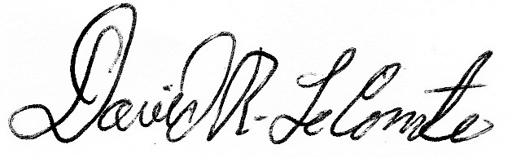

________________________________________
David LeComte – Chairman

