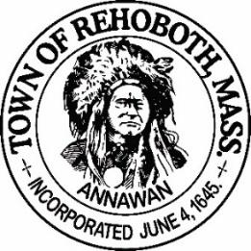

REHOBOTH TOWN EVENTS COMMITTEE

Meeting Minutes

Location: Rehoboth, Massachusetts, remote via Zoom
Date: June 14, 2021 at 6:00 pm

Attendance: David LeComte, Jennifer LeComte, Odete LaCourse, Sheila Kramer and Paula Katon (Guest)

Absent: None

Motion to approve the minutes from May 24, 2021 was made by Sheila, seconded by Odete. Discussion: None. All in favor.

Agenda Items:
Recruitment update: Dave made a post on Facebook looking for volunteers. We need someone that can help us with the Facebook page. Currently we are using Rehoboth Talk to advertise our events. We welcomed Paula Katon to the meeting. She is new to Rehoboth and joined the meeting tonight to see what the Events Committee is all about. We explained to about her our mission and what we have put on in the past and what we are planning for the future.
Town Events Facebook page: Dave started setting up our Face Book page but not complete yet.
Wine Tasting Event: We need to get a One-day liquor license at a cost of $25. The vendor will supply 5 different wines. The venue is the Anawan Club, 13 Gorham St on July 9th.We are not selling the wine but guests may purchase wines from the vendor. Maximum of 40 guests. We need to decide how payment will work and get the flyers out soon. We had previously discussed having cocktails available after the tasting but we will hold on this idea for now.
Finance report: Our current balance is $1567.28. No change from the last meeting. Odete moved to accept the finance report as stated, Sheila seconded and all in favor.
Movie Night: No updates at this time.
Rehoboth Town Fair: We has had a lot of very positive remarks concerning the fair on social media. Maribeth Moriarty still has not responded. Dave spoke at the BOS meeting about the possibility of the town fair and possibly having it at Francis Farm. They gave us their blessing but did not give us a positive answer on the Farm. George Solas will be the liaison for the Town Events Committee now. Sherri Savoy from the Horse Breed Expo met with us and had a lot of great ideas and timeline (organizational chart) for setting up the fair. Chuck Procopio from Harvest Block Party was very enthusiastic about collaborating with us. Before we can proceed, we need a venue. If Francis Farm is not available, we could possibly use Nike Field. We will probably have to aim for next summer for the fair unless the Harvest Block Party committee wants to combine efforts for this year.
New Business: None
Next Meeting: July 26th at 6:00 via Zoom.
Motion to adjourn at 6:39 pm was made by Jen, seconded by Odete and all in favor

Respectfully submitted,

Jennifer Lecomte
Clerk – Town of Rehoboth Events Committee

Meeting Minutes Approved (date and time):

Date: _8/2/2021 Time: _11.15

Signature of The Town Event Committee Chairman
after minutes have been approved:
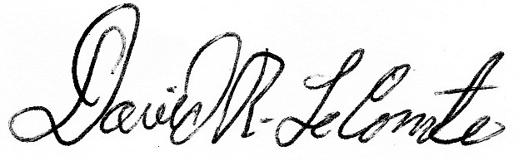

________________________________________
David LeComte – Chairman

