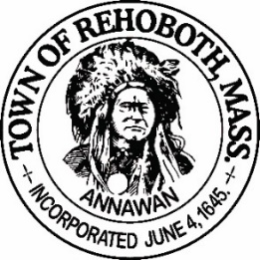

REHOBOTH TOWN EVENTS COMMITTEE

Meeting Minutes

Location: Rehoboth, Massachusetts, remote via Zoom
Date: April 26, 2021 at 6:00 pm

Attendance: David LeComte, Jennifer LeComte, Odete LaCourse and Sheila Kramer and guest Michael Fleming

Absent: None

Motion to approve the minutes from January 25, 2021 was made by Sheila, seconded by Odete. Discussion: None. All in favor.

Both meetings in February and March were canceled due to a lack of quorum.

Agenda Items:
Committee update: Both Liz Fischbach and Dawn Crooks have submitted their resignations. We have received two talent bank forms for Laura Samsel and Katy O’Rourke-Wilson. Hopefully they will be accepted at the BOS meeting soon. There are two more people that have expressed an interest in joining but have not submitted talent bank forms yet.
Town Events Facebook page: Dave started setting up our Face Book page but not complete yet.
Town website updates: Odete needs to update the calendar on the town website and remove the Taste of Rehoboth for 2021. Currently, we have no events in the calendar.
Wine Tasting Event: Dave had spoken to Chris Gasbarro about a tasting event but Chris backed out. Odete is still working with another vendor and also someone local that may be willing to do it. He has 40 different wines to work with. We would like to pursue this for June of 2021. We are working on the logistics of how it would work, how many sessions, how to sell it. We discussed keeping it as a smaller more intimate event. We would need at least 40 people to start though. Odetes contact would set up the link and promote it and also collect the fees. Wine would be shipped directly to the participants. We would probably plan multiple tastings but only promote one at a time. Odete made a motion to pursue the wine tasting event, Sheila seconded it and all in favor. We will vote on it at the next meeting.
Finance report: Our current balance is $1567.28. No change from the last meeting. Odete moved to accept the finance report as stated, Sheila seconded and all in favor.
Scavenger Hunt: Dave has been in touch with a group called Action Bound that runs scavenger hunts. They handle all the set up. Their hunt involves scanning codes and receiving points for getting to the location and once there, there is a task to do and a photo to take. The down side is the cost. It would cost $30/family. We need to look into this further before committing. Dave will do some more research before the next meeting. The group thought this was a lot more complex and costly than originally envisioned, even without the cost of the prizes. Will discuss further options at the next meeting.
Movie Night: Odete will pursue this for August and will get some pricing.
New Business: Now that business is starting to open up a bit, we can start planning some events. Dave put out a “feeler” on Rehobothtalk about possibly bringing back the Rehoboth Town Fair. There were over 100 positive, very enthusiastic comments on this. This would include exhibitions, booths, food, entertainment, rides etc.… Dave spoke with Journey’s Haven about pony rides, petting zoos, horse and buggy rides. We could also have a cook off with locally sourced ingredients, a bake off, tractor pull or an antique tractor show. It could possibly run for several days and have a different “specialty” every night. It will be a big project so probably not for this summer. We discussed combining forces with other committees i.e., Parks Commission, Agricultural Commission, Farmers Market and Harvest Block Party. We would also need to have a venue that can support this and we would tailor the event to the size of the venue. We all agree that it would be a great idea. Motion was made by Odete to pursue the idea of a town fair and continue research into the details, Seconded by Sheila and all in favor.

Next Meeting: Monday May 24th at 6:00 via Zoom.
Motion to adjourn at 7:00pm was made by Jen, seconded by Dave and all in favor

Respectfully submitted,

Jennifer Lecomte
Clerk – Town of Rehoboth Events Committee

Meeting Minutes Approved (date and time):

Date: __5/24/21__________________ Time: __1800_____

Signature of The Town Event Committee Chairman
after minutes have been approved:

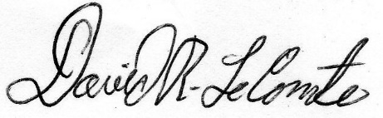
________________________________________
David LeComte – Chairman

