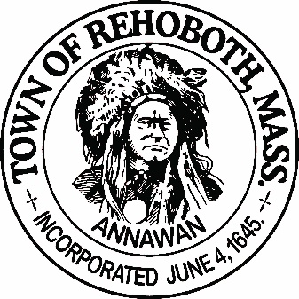

REHOBOTH TOWN EVENTS COMMITTEE

Meeting Minutes

Location: Rehoboth Town Offices, Rehoboth, Massachusetts
Date: 6:00 PM, February 26, 2019

Attendance: Jake Kramer, David LeComte, Jennifer Lecomte, Sheila Kramer, Deborah Breckenridge and Kim Fagundes

Absent: none

Motion to approve the minutes from January 29th was made by Jen, seconded by Deborah. All in favor.

Agenda Items:
Old business:
Francis Farms contract: As of this time it is still not finalized. Odette and Jay Talerman are working together on it. The kitchen is not available for any vendors to use. Hopefully the contract will b finalized by next week and it will be used yearly after that (except changing the dates).
Vendor agreements: Sarah (Town Counsel) wrote up an initial draft of the agreements. Upon review of the committee it was decided to remove the line “legal representative” and change it to “authorized representative”. There was also a duplicate line, section H & I so one needs to be removed.
Taste of Rehoboth subcommittee:
Dave and Deborah updated the committee on progress on the Taste of Rehoboth: All is going along well. We have 15 Restaurants and 8 Farms committed to coming. Kim will visit the Farmers and have them “sign up” rather than just a verbal agreement. Dave supplied her with the form he used for signing up the restaurants.
The Taste of Rehoboth subcommittee has decided to use Eventbrite to handle the ticket sales. We will also sell paper tickets at a few selected locations around town. Jake will handle ticket sales from the town offices. Suggested locations to sell tickets included: Bristol County Savings Bank (already offered to do so), Vino’s, Anawan Pharmacy and the American Legion. The American Legion may be a conflict of interest so we need to research that first). We need to have these locations have accountability for tickets (number the tickets) and collect money prior to the event.
Promotion and requests for donations are on hold until the contract is signed with Francis Farm.
Floor Plan: David and Jennifer went to Francis Farms and measured out the room.
Deposit: The deposit for Francis Farms needs to come from the 375th committee. After the event, we will make a direct deposit to the 375th committee. A new revolving account for Town Events Committee needs to be voted on at the Town Meeting in May.
Banners and Signage: Kim suggested that we spend a little up front for items that can be used yearly i.e. a Banner, sign holders for the tables. Jake says to hang onto all the receipts for reimbursement after the town meeting.
Reminder that all flyers should include “Supporting the Rehoboth 375th”
Silent auction and raffles: Sheila and Deborah are working on this.

Items required from the Town Events Chairman from the Taste of Rehoboth committee:
Jake needs the contract with Francis Farms and the Vendor agreements done. He will expedite these.
New Business:
Alexander Williams event with the 54th Regiment. On September 22nd, The Cemetery committee will be running a ceremony at the cemetery with a dinner following at the Carpenter Museum. This event is being promoted by Jake and the Town Events Committee but the Cemetery committee will be handling everything.
Kim suggested having a Holiday Historic Homes Tours. She will find out who was in charge of this for the 375th year celebration and see if she would be interested in running this again.
Memorial Day Parade: This is handled out of the Veterans Offices. Jake will take lead on the parade. In Aprils Rehoboth Reporter, the first public meeting for the parade will be posted.
Next Meeting: March 26th at 6:00 at the Town Offices.
Motion to adjourn at 7:25pm was made by Jen, seconded by Kim, all in favor

Respectfully submitted,

Jennifer Lecomte

Meeting Minutes Approved (date and time):

Date: ___________________________ Time: ____________

Signature of The Town Event Committee Chairman
after minutes have been approved:

________________________________________
John “Jake” Kramer – Chairman

