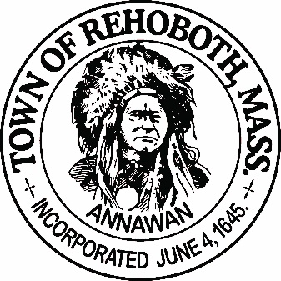

REHOBOTH TOWN EVENTS COMMITTEE

Meeting Minutes

Location: Rehoboth Town Offices, Rehoboth, Massachusetts
Date: 6:00 PM, March 26, 2019

Attendance: Jake Kramer, David LeComte, Jennifer Lecomte, Sheila Kramer and Kim Fagundes

Absent: Deborah Breckenridge

Motion to approve the minutes from February 26th was made by Jen, seconded by David. All in favor.

Agenda Items:
Old business:
Francis Farms contract and Vendor Agreements: These are finalized and will be used as a template for years to come.
Alexander Williams event and Memorial Day Parade: No further business to report on at this time.
Taste of Rehoboth subcommittee:
Dave updated the committee on progress on the Taste of Rehoboth: All is going along well. We have 15 Restaurants and 4 Farms committed to coming. Still reaching out to a few more.
Ticket sales: The Town Clerks office will handle online ticket sales and printed ticket sales at the Clerks window. The subcommittee will be responsible for delivering the online ticket sales to the buyers unless they want to pick them up at the door. Suggested locations to sell tickets included: Bristol County Savings Bank, Vino’s, Anawan Pharmacy and the town offices. There will be a cut off date for online sales one week prior to the event. We discussed raising the price of the ticket to $25 one week prior to the event for all printed ticket sales.
Promotion and requests for donations have been mailed out. Sheila is tracking donations. Deborah has been working hard on posting the event to all the social media sites. We will be sending out weekly updates on social media. The Rehoboth Reporter and Rehoboth 411 would like to run an article on the Taste of Rehoboth for May’s issue.

Finances: Jennifer will be keeping track of all the finances related to the Taste of Rehoboth. Jake will supply her with a form from the accounting office to record donations. We will hold all checks until we find out the exact amount needed to pay off the 375th debt in mid-June. The 375th committee still has proceeds coming in from Anawan Pharmacy and the golf tournament which will contribute to paying off the debt. After that is resolved, the revolving fund will be set up.
Deposit: The deposit for Francis Farms needs to come from the 375th committee. This will be voted on at the next 375th committee meeting April 5th.
Vendor packets: Dave and Jennifer have been updating the vendor packet and will be visiting the vendors soon.
Silent auction and raffles: Sheila and Deborah are working on this. Donations have begun to come in. Sheila will set up a spread sheet to track donations.
Back up information: Jake would like all documents created in relation to the Taste of Rehoboth, shared with the Towns shared drive. This gets backed up often so information will never be lost. When all is done, send the information to Jake and he will upload it to the drive. Basically a “How to run the Taste of Rehoboth” manual.
New Business:
Alexander Williams event with the 54th Regiment. On September 22nd. This event is being promoted by Jake and the Town Events Committee but the Cemetery committee will be handling everything.
Memorial Day Parade: This occurs on May 27th. Handled by the Veterans office following the same format as past years.
Profits from the town events: What happens to the profits from events? Do we give back to the community? Does it go toward the towns 400th anniversary? Does it serve as seed money for future events? Does its rollover from year to year or does it need to be zeroed out at the end of the year? Discussion for a future meeting.
Next Meeting: April 23rd at 6:00 at the Town Offices.
Motion to adjourn at 7:30pm was made by Jen, seconded by Dave, all in favor
Respectfully submitted,

Jennifer Lecomte

Date: ___________________________ Time: ____________

Signature of The Town Event Committee Chairman after minutes have been approved:

________________________________________
John “Jake” Kramer – Chairman

